***Spring BOOT Hanin*🎀**

Spring Container**:** the core of the Spring Framework. It is responsible for managing the lifecycle of objects (beans) and injecting their dependencies. It plays a central role in achieving two key concepts: Inversion of Control (IoC) and Dependency Injection (DI).

Create and Manage Objects **(Inversion of Control—IoC):** This is a design principle in which control over certain parts of the code is inverted by giving responsibility for creating objects to the **Spring Container**. This principle allows for greater flexibility and decoupling in software design.

Inject Object Dependencies **(Dependency Injection - DI):** a specific technique to implement IoC, is a design pattern used in Spring to provide the required dependencies of an object. Instead of an object creating its own dependencies, the container injects these dependencies automatically. This makes the code easier to maintain, test, and extend.

- Constructor injection: Dependencies are provided through a class constructor “when you have required dependencies “.

- Setter Injection: Dependencies are set using setter methods ”when you have optional dependencies ”.

- Field Injection: Dependencies are directly injected into class fields, often using annotations Spring. 🡪 no longer cool, make code harder to unit test.

* IoC and DI allow Spring to handle object creation and wiring, letting developers focus on writing business logic rather than managing object lifecycles manually.

“@Qualifier”: when you have multiple beans of the same type, Spring will not know which bean to inject if you use @Autowired alone. This can be resolved using @Qualifier, which defines the bean name to be injected.

- **Bean Names**: The name provided in the @Qualifier should match the bean name. Spring typically uses the class name (with the first letter in lowercase) as the default bean name unless specified otherwise.

- Works alongside @Autowired, @Inject, and even @Primary.

- useful in scenarios where you need precise control over which implementation to inject.

“@Primary”: marks one bean as the default bean for injection when there are multiple candidates for auto wiring.

* Multiple @Primary causes an Exception, You can have only a single @Primary annotation in the Application.
* @Qualifier overrides @Primary. Using @Qualifier will always choose the bean you explicitly specify, even if another bean is marked as @Primary 🡪 @Qualifier has more priority than @Primary.

**Lazy Initialization in Spring:** In Spring, by default, beans are eagerly loaded ( created and initialized ) as soon as the application context is loaded. Lazy **initialization** refers to the practice of deferring a bean's creation (or initialization) until it is needed, rather than at application startup. ”Only initialize and create beans when needed”.

Spring Bean Scopes: **A bean's scope** defines its lifecycle, specifically when it is created, how long it lives, and when it is destroyed.

Types of Bean Scopes in Spring:

Singleton (Default Scope): Only **one instance** of the bean is created for the entire Spring application context, and this instance is shared across all requests.

**Lifecycle**:

* Created when the application context is initialized.
* Destroyed when the context is closed.

Prototype: A **new instance** of the bean is created each time the bean is requested from the container.

**Lifecycle**:

* Created each time a bean is requested.
* Spring does **not manage the destruction** of prototype beans.

**Request** (For Web Applications): A **new instance** of the bean is created for each HTTP request. Once the request is processed, the bean is discarded.

**Lifecycle**:

* Created when an HTTP request starts.
* Destroyed after the request is completed.

**Session** (For Web Applications): A **new instance** of the bean is created for each HTTP session. The same bean instance is used across multiple requests within the same session, suitable for storing session-scoped data, such as user login information.

**Lifecycle**:

* Created when a session starts.
* Destroyed when the session expires or is invalidated.

**Global Session** (For Portlet-Based Web Applications):**new instance** of the bean is created for each global HTTP session, which is specific to **portlet-based** applications (not common in standard Spring MVC applications).

* **Singleton** is commonly used when the bean can be shared across requests.
* **Request** and **Session** scopes are more suitable for web-specific components that deal with user requests or sessions.

Bean Lifecycle Methods/Hooks in Spring: manage the lifecycle of a Spring bean. These hooks allow you to customize beans' initialization and destruction behavior, giving you more control over their lifecycle within the Spring container.

Bean Lifecycle in Spring:

1. **Instantiation**: The Spring container creates the bean instance.

* Use @PostConstruct for simplicity and readability.
* Use afterPropertiesSet() when you prefer to implement the interface.
* Use init method in configuration for externalized initialization logic.

1. **Property Population**: Spring injects the required dependencies into the bean.
2. **Initialization**: Spring executes the initialization methods (custom hooks like @PostConstruct or afterPropertiesSet().
3. **Ready for Use**: The bean is ready to be used by the application.
4. **Destruction**: The bean is removed from the container and destroyed, for cleanup:

* Use @PreDestroy for simplicity and automatic cleanup.
* Use destroy() when implementing the interface is preferred.
* Use destroyMethod in configuration for externalized cleanup logic.
* **Initialization** logic works as expected (@PostConstruct), but **destruction** methods (like @PreDestroy) are **not automatically called** for prototype beans.

ORM: Application 🡪 ORM(JPA🡪vendor(Hibernate))🡪Database.

**ORM** stands for **Object-Relational Mapping**.

* It's a technique that helps developers map and convert data between two incompatible systems: the **object-oriented programming model** (like in Java) and the **relational database** (like SQL database) without manually writing SQL queries.
* ORM tools provide the mechanism to:
* **Persist objects** (store them in a database).
* **Retrieve objects** (fetch data from the database).
* **Update objects** (change data in the database).
* JPA: persist data between Java object & database.

Acts as a bridge between OO models & database.

Implemented by ORM tools like Hibernate/ TopLink/ iBatis as it’s just a specification, that doesn’t perform any operations by itself.

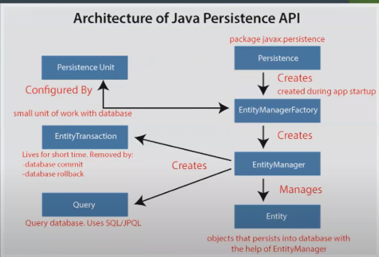

Key JPA Concepts:

* **@Entity**: Annotation to mark a class as a persistent entity (i.e., a class that maps to a database table).
* **@Id**: Annotation to mark a field as the primary key.
* **@Table**: Used to specify the table name in the database for the entity.
* **JPQL (Java Persistence Query Language)**: A query language similar to SQL but operates on Java objects/entities.

Hibernate: open source Java framework simplifies the development of Java applications to interact with the database.

* Hibernate extends JPA with extra features, but at its core, it is a **JPA provider**.
* implements all the guidelines provided by JPA and adds more powerful features like **caching, lazy loading, and batch processing**.
* **Mapping Annotations**: Hibernate allows you to map Java classes to database tables and columns using JPA annotations like @Entity, @Table, etc.
* **SessionFactory**: Hibernate’s mechanism for creating and managing database connections and sessions.
* **HQL (Hibernate Query Language)**: A more powerful query language built on top of JPQL with additional features.

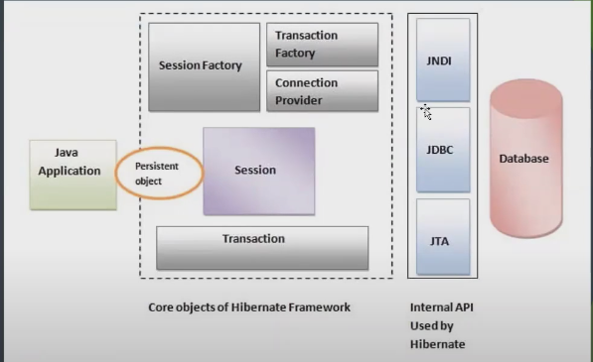

* **ORM** is the concept or technique for mapping objects to relational databases.
* **JPA** is a **standard specification** that defines how Java applications should use ORM.
* **Hibernate** is an **implementation of JPA**, providing actual tools and functionality to work with databases using ORM.
* **Spring JDBC**: a framework that simplifies working with databases using JDBC. includes:
  + **DataSource**: Manages connections to the database.
  + **JdbcTemplate**: Provides an easier interface for executing queries.
  + **NamedParameterJdbcTemplate**: Supports named parameters in queries.

C**onfiguration in “application.properties”:**

* Contains settings for database connection such as URL, username, and password.
* **Connection pooling: mechanism** can be enabled to improve performance by reusing connections, allocating new connections, managing available connections, and closing connections.

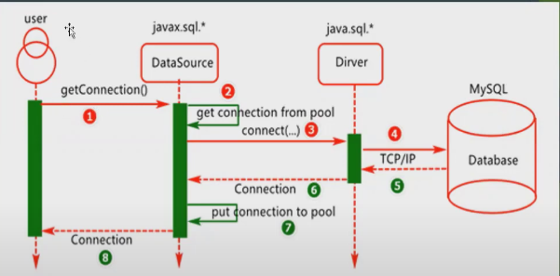

* Configuration types:
* XML / Java based / Annotations

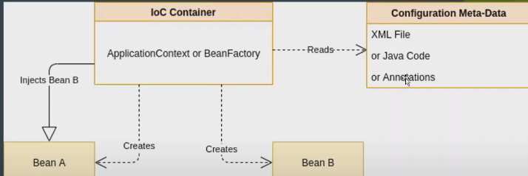

Annotations: metadata provides data (supplemental information) about the program

1. @Autowired: dependency injection 🡪used on setter methods, variables, and constructors. Spring manages & creates the necessary objects.
2. @RestController: Combines @Controller and @ResponseBody. It indicates that the class handles HTTP requests and returns JSON/XML responses.
3. @RequestMapping: Maps HTTP requests to handler methods. It defines the endpoint path and the HTTP methods (GET, POST, DELETE…).
4. @component: class-level annotation indicate a class is a Spring class(as a Bean)) to be discovered & managed by Spring during the classpath.
5. @SpringBootConfiguration:  
   Indicates that the class provides configuration settings for the Spring Boot application.
6. @Configuration: indicate that a class contains one or more definitions to be managed by Spring Controller.
7. @Bean: used inside a class with @configration to indicate. that a method returns an object that should be managed as a Bean by spring.
8. @Service: Marks the class as a service component in the service layer. It holds business logic and orchestrates interactions between different parts of the application.
9. @Repository: Used to indicate that the class provides CRUD operations on a database. It marks the class as a Data Access Object (DAO).

Controller Layer: responsible for handling incoming HTTP requests, returning appropriate responses, and serving as an entry point for users(frontend) to interact with the backend.

Service Layer: contains the core business logic. It acts as a middleman between the controller and repository layers, ensuring the proper business rules are applied.

Single Responsibility Principle (SRP**)**: states that every class, function, or module should have **only one reason to change**. In other words, it should handle one specific responsibility only.

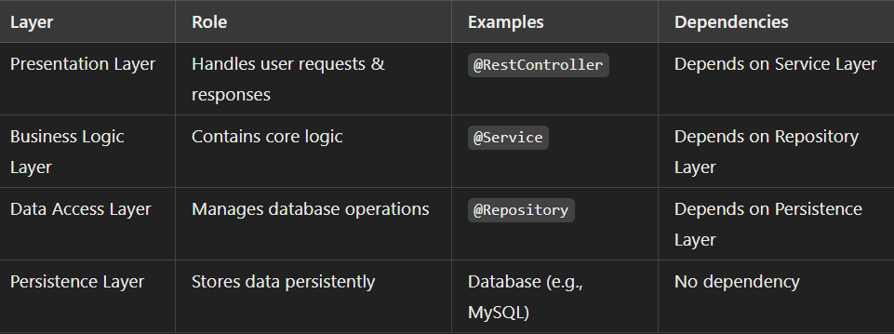

***Entity Lifecycle Model in JPA & Hibernate***

Cascading Operations:

* PERSIST:- When you **persist** (save) a parent entity, the associated child entities are also automatically saved.

**Example**: If you save a Person object, the Address object linked to that Person will also be saved in the database.

* MERGE:- it updates the existing data in the database with the data from the entity you provided.

**Example**: If you update a Person object and merge it, the database will update the existing record with the new data, and the same will happen for the linked Address object.

* REMOVE:- When you **remove** an entity, it deletes the corresponding row from the database.

**Example**: If you delete a Person object, the Address object linked to it will also be deleted from the database.

* DETACH:- **Detach** means removing an entity from the persistent context, so it’s no longer tracked by JPA.

**Example**: If you detach a Person object, the Address object linked to it will also be detached, meaning JPA will stop tracking any changes you make to these objects.

* REFRESH:- means reloading an entity's data from the database, undoing any changes you made since it was last loaded.

**Example**: If you made some changes to a Person object and then use refresh, those changes will be discarded, and the Person object will be restored to its original state from the database.

* **Transient**:- The entity is new and not associated with any persistence context.

* ALL:- ensure that all the cascade operations apply to the child entities, effectively managing the entire object graph as a single unit.

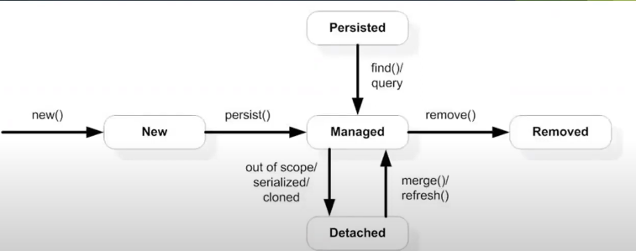

* + - * PERSIST and MERGE are for saving and updating.
      * REMOVE and DETACH are for deleting and stopping tracking.

Data JPA Projection: When working with databases, you might not always want to retrieve entire entities; instead, you may need just a subset of data. Projections in Spring Data JPA allow you to fetch specific columns (fields) from an entity. This can optimize performance by reducing the amount of data loaded into memory and simplify the handling of data.

* Interface-based Projection:

specify the data you want to fetch by declaring an interface with methods corresponding to the entity fields you want to retrieve.

* Interface-Closed Projection: the accessor methods of the projection interface match the properties of the target aggregate (entity). This means all the methods correspond to actual fields in the entity. Like 🡪getName(),getPrice()…
* Interface-Open Projection: allow you to define methods in the projection interface that do not directly map to entity fields. Instead, you can use custom expressions, such as concatenating fields or applying transformations using the “@Value” annotation.

ex: firstName form entity + lastName from entity = fullName in interface.

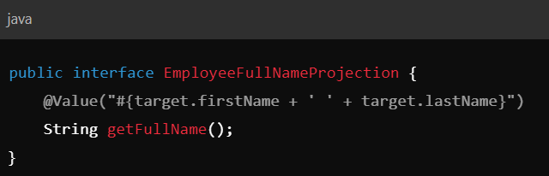

* Constructor-based Projection: **Constructor-based Projections** allow you to retrieve specific columns from a database and map them directly to a Data Transfer Object (DTO) or a custom class using a constructor. This type of projection is useful when you want more control over the data, such as performing custom transformations, validations, or logic inside the DTO.

Interface & Constructor Based Projection

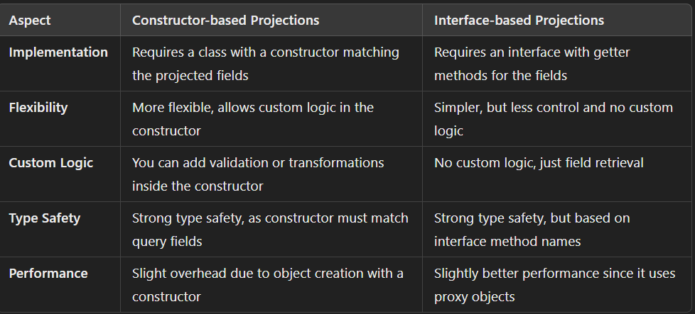

Transaction: essential for ensuring that a group of operations either all succeed or all fail. If any operation fails, the whole transaction can be rolled back

*“@Transactional”*: Class / Method annotation with attributes:

* **Propagation:** Controls how transactions behave when calling other transactions.
  + REQUIRED**:** Uses the current transaction or starts a new one.
  + REQUIRES_NEW**:** Always creates a new transaction.
  + SUPPORTS**:** Uses a transaction if one exists; otherwise, runs without.
* **Isolation:** Manages data visibility between transactions.
* READ_COMMITTED**:** Only sees committed changes (default).
* SERIALIZABLE**:** Ensures full isolation, highest level.
* **Timeout:** Sets the maximum time a transaction can run before it's aborted.

🡪 @Transactional(timeout=30) means the transaction will be aborted if it runs longer than 30 seconds.

* **readOnly:** Optimizes transactions for read operations by marking them as read-only. @Transactional(readOnly=true)
* **rollbackFor/noRollbackFor:** Specifies which exceptions should or shouldn't trigger a rollback.

You can prevent rollback on certain exceptions, even if they are unchecked

@Transactional (noRollbackFor=IllegalArgumentException.class).

Validation is Spring: Bean Validation in Spring works by applying constraints to the fields of a class, ensuring that they meet certain conditions. This allows for automatic data validation, ensuring that inputs are valid before processing.

Key Annotations: Spring supports Hibernate validator by adding annotations to fields.

* **@Validated**: class-level annotation tells Spring to validate parameters passed into a method of the annotated class.
* **@Valid**: used at the **method parameters** or **fields level** to validate method inputs.
* **@NotBlank**: ensure that the string input/attribute is not null or empty “must have at least one non-whitespace character”.
* **@Min**: Ensures that a numeric field has a value **greater than or equal to** a specific value.
* **@Max**: Ensures that a numeric field has a value **less than or equal to** a specific value.
* **@Pattern:** Used for fields that need to follow a specific format, like phone numbers, postal codes, and IP address... as matching the given regular (regex).
* @Email: ensure that the string field contains a valid email address according to standard email format.

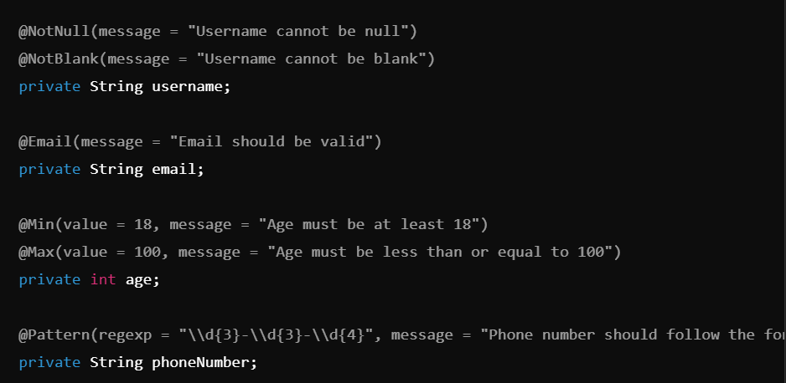

Use Entity Graphs (Fetch and Load): in JPA are used to specify how related entities should be fetched from the database. This allows you to control which associations should be loaded to avoid unnecessary data fetching.

* Fetch Graph: to load only the essential data to optimize performance by fetching only a specific subset of entity relationships and ignoring the default Eager or Lazy loading behaviors.” **limit** the data fetched strictly”

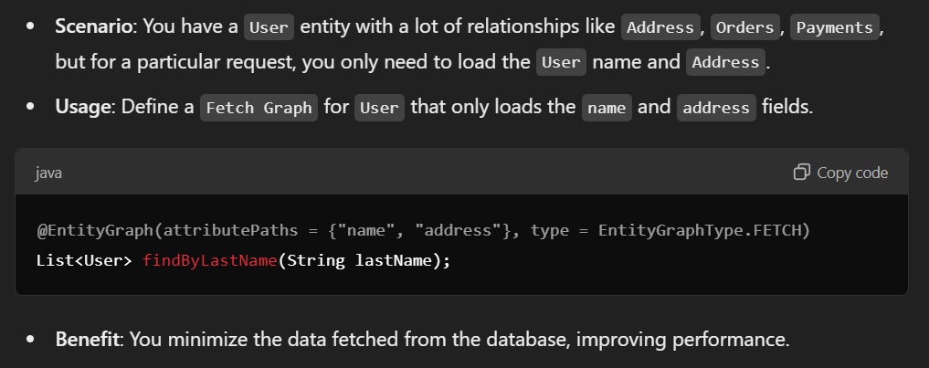

* Load Graph: fetch all Eager fields **and** include(add) extra Lazy fields that are not loaded by default.

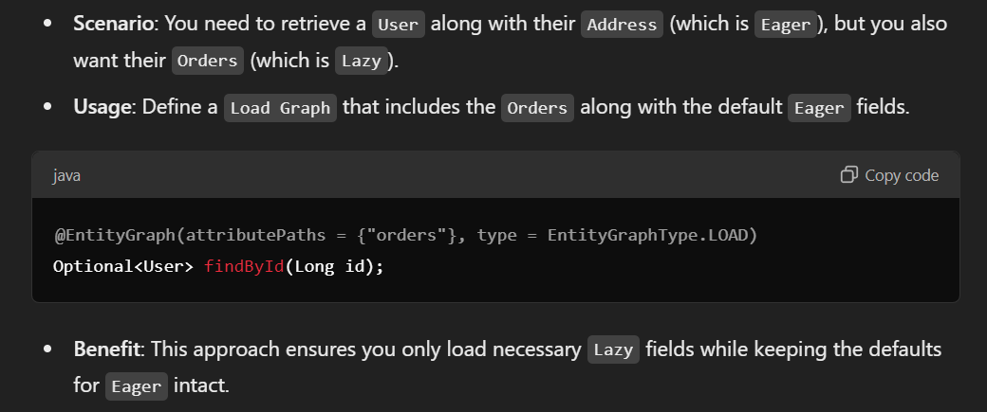

@EntityGraph Annotation: to define and apply Fetch or Load Graphs. This allows you to specify which relationships or attributes to load as part of the query execution without changing the default fetch type of the entity mappings, You can define a graph in the entity using @NamedEntityGraph or reference it with @EntityGraph in your queries

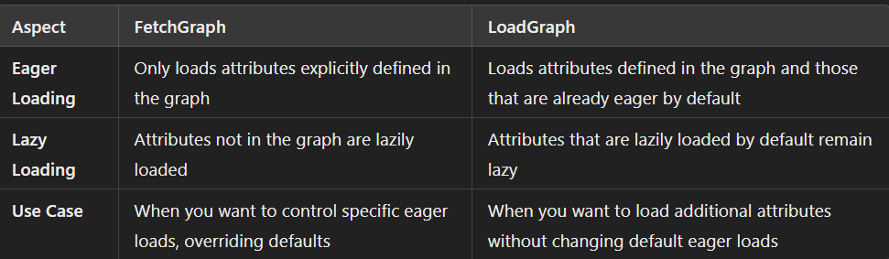

Benefits of Fetch and Load Graphs:

1. Performance Optimization: Helps reduce unnecessary loading of large relationships unless explicitly needed, reducing memory and bandwidth overhead.
2. Fine-grained control: You have control over what associations are loaded for each query, making it flexible for different use cases.
3. Simpler than Custom Queries: Instead of writing complex JPQL or SQL queries to load specific associations, you can use entity graphs to control fetching.

JPA Fetch Type: how associated entities are retrieved from the database.

* Lazy Fetch: associated data is fetched only when needed, which is the default for many-to-many and one-to-many relations.

**When to use?**: Use lazy fetching when the associated data is **not always needed** and you want to load data only when it is requested.

**\*** **Can cause the N+1 Query Problem, where multiple queries are executed to fetch related entities, increasing query execution time.**

* Eager Fetch: With eager fetching, related entities are **fetched immediately** along with the primary entity. This means that when the primary entity is retrieved, all associated data is fetched in the same query.
* which is the default for many-to-one and one-to-one relations.

**When to use: When you know that the associated data will always be needed when retrieving the primary entity and** want to avoid additional queries later.

JPA Auditing: easily manage the tracking of entity changes in a clean and automated way, reducing the need for manual record-keeping of user actions and timestamps.

* + The auditing feature in Spring Data JPA can be activated using annotations like @CreatedBy, @LastModifiedBy, @CreatedDate, and @LastModifiedDate.
  + **AuditingEntityListener** automatically updates the relevant fields when an entity is persisted or updated.
  + **AuditorAware** must be implemented to provide the current user responsible for changes.

### **@CreatedBy and @LastModifiedBy:** These annotations are used to capture **who** created or modified an entity.

* **@CreatedBy**: store the user who originally created the record.
* **@LastModifiedBy**: store the user who last modified the record.

@CreatedDate and @LastModifiedDate: These annotations capture the timestamps of when an entity was created or last modified.

* **@CreatedDate:** This field will store the **date** and **time** when the entity was created.
* **@LastModifiedDate**: This field will store the **date** and **time** when the entity was last modified.

Sorting & pagination:

**Sorting:** arranging data in a specific order, like ascending or descending.

* **to Implement Sorting:**
  + **Using PageRequest:** When you create a PageRequest object, you can specify sorting along with pagination.
  + **Using Sort Directly:** You can also use the Sort object alone to define sorting criteria.
* **fields you use for sorting must directly match the names of the fields in your domain model class or the aliases used in your JPQL query. This ensures that the sorting operation correctly references the data structure in your code.**

**Pagination**: dividing a large set of results into smaller, manageable pages.

* **To implement Pagination:**
  + **Using Pageable:** The Pageable interface holds details about the requested page, such as:
    - **Page size:** The number of items on each page.
    - **Page number:** Which page you are currently viewing.
    - **Sort information:** Sorting can be combined with pagination using a Sort object.

Locking Mechanisms: Optimistic vs Pessimistic

* **Optimistic Locking**: Uses a version column to prevent concurrent modifications. Throws an OptimisticLockException if another transaction has updated the entity.
* **Pessimistic Locking**: Prevents others from modifying the entity by locking it during a transaction, potentially causing **deadlocks**.
* Use optimistic locking in scenarios with high concurrency to avoid unnecessary database locks.

**Exceptions in Spring**

**Request Flow without an Exception**

1. REST Client sends an HTTP call to the Spring Application, targeting the Controller layer.
2. The Controller handles the HTTP request and forwards the necessary business logic to the Service layer.
3. If the Service layer completes its operation without errors, it returns a response to the Controller.
4. The Controller sends the response back to the REST Client.

Request Flow with an Exception

1. If the Service layer encounters an error (e.g., a business logic exception), it throws an exception.
2. The Controller layer does not handle the exception directly. Instead-by default-, it is passed to a special class known as the RestExceptionHandler (part of the Spring Exception Handling mechanism).

* RestExceptionHandler: responsible for catching the exception and encapsulating the error details into an **ApiError object**.

The **ApiError object** typically contains information such as:

* **HTTP Status Code** (e.g., 400 Bad Request, 404 Not Found)
* **Error Message**: A description of the error that occurred.
* **Timestamp**: When the error happened.
* **Details**: Any additional information related to the error (e.g., validation error details).

Handle Exceptions Components in Spring:

**“@**ControllerAdvice” : Applied at the **class level** and works across all controllers.

* Used to handle exceptions **globally** across all controllers in the application by Combine with **“@ExceptionHandler()”**.
* Allows to centralize exception handling logic, so all controllers benefit from consistent error handling.

**“@ExceptionHandler()”**

* Defines **specific exceptions “Locally”** handled by methods in the controller or in a class annotated with “@ControllerAdvice” .Each method can handle different exceptions.
* For example, one method could handle NullPointerException, while another handles EntityNotFoundException.

Note:

* You can use @ResponseStatus with @ExceptionHandler to define the HTTP status associated with a specific exception.

